**WINDOWS INSTALLATION GUILDE FOR LOCAL MACHINE**

# Perquisite

* Download Jenkins [package](https://get.jenkins.io/windows/2.440/jenkins.msi).
* Download Java 11 this [link](https://www.oracle.com/java/technologies/javase/jdk11-archive-downloads.html#license-lightbox).
* Create Jenkins user on machine.
  + Run Command Line Interface with Admin privileges with command: “net user /add [username] [password]”
* Add privilege for user to logon as a service:
  + Search for Local Security Policy

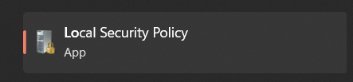

* + On “Local Policies/User Right Assignment/Log on as Service” then click on “Add user or group” on add user name on object names Ex: Jenkins.

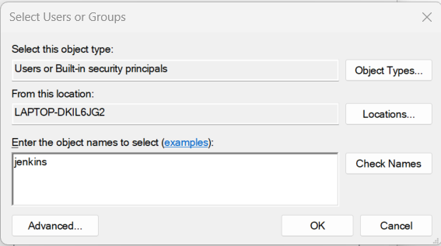

# Install

* Open Jenkins.msi

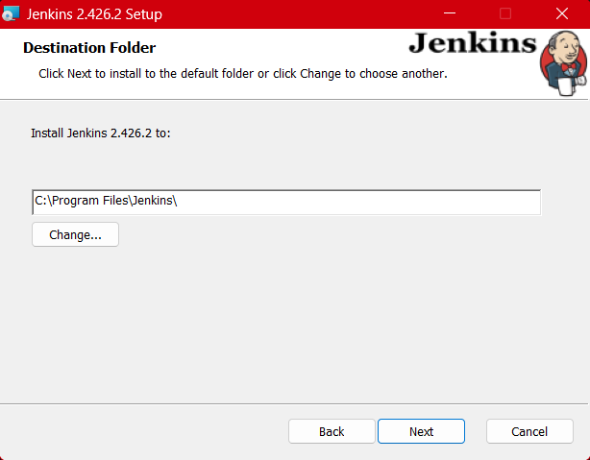

* Click Next and you will direct to Jenkins service login credentials. On logon type chose Run service as local or domain user, enter Account and Password you have set.

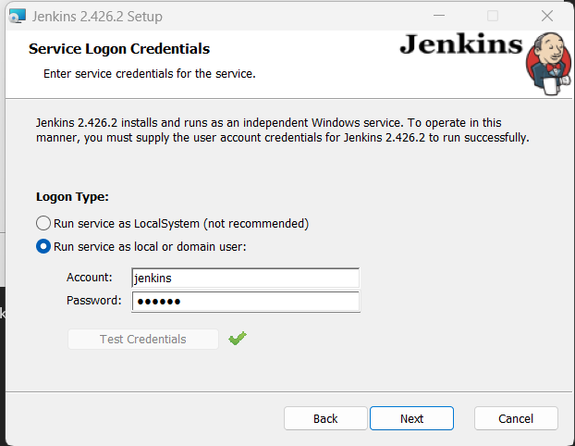

* Then click Next and you will direct on Port Selection. Ex: 8085

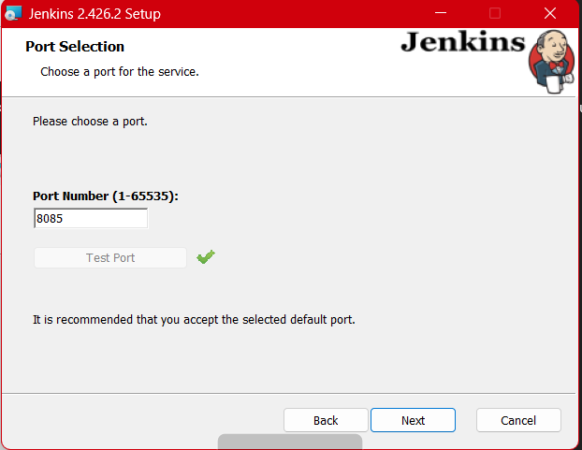

* Then choose java install path. Ex: “C:\Program Files\Java\jdk-11\”
* Click “Install”

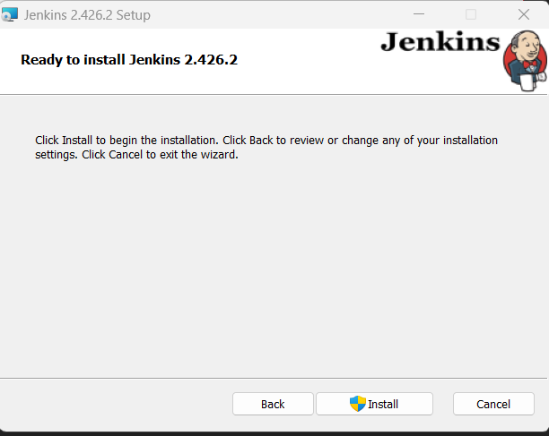

* On browser go to: localhost:8085

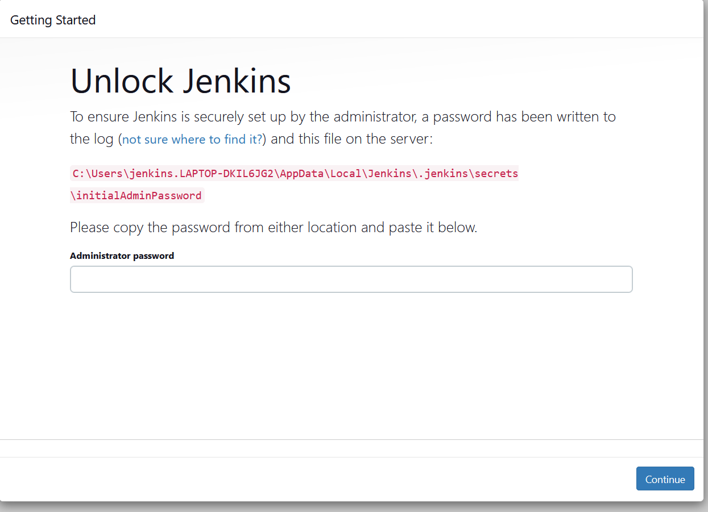

* Then open Command Line Interface as Admin and enter: “more C:\Users\jenkins.LAPTOP-DKIL6JG2\AppData\Local\Jenkins\.jenkins\secrets\initialAdminPassword” will show password for Jenkins login